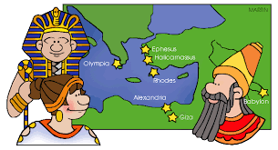
7thGrade Social Studies
2019-2020
Mrs. Kari Shagena
Room 500
Phone: 727-7552 ext. 2500
WebPage: www.kshagena.weebly.com
Email:
kshagena@richmond.k12.mi.us
Prep Hour: 2nd hour
Mrs. Cheryl Jahr
Room 300
Phone: 727-7552 ext. 2300
WebPage: www.cjahr.weebly.com
Email: cjahr@richmond.k12.mi.us
Prep Hour: 2nd hour

Welcome to 7th grade Social Studies.
This course follows the curriculum set forth by the State of Michigan. Student achievement is measured according to the Grade Level Content Expectations stated in that curriculum. These Grade Level Content Expectations can be found at the following link: https://www.michigan.gov/documents/mde/Draft_Social_Studies_Standards_201903_650081_7.pdf

Curriculum:
The seventh grade social studies curriculum focuses on ancient world history and geography. Students begin their exploration into world history with a focus on historical thinking. Students learn that historians must have some evidence to support the claims they make in their accounts. They investigate how these social scientists select, analyze, and organize evidence, and then use that evidence to create accounts that answer questions or problems. Students then investigate human history from the beginning until around 1500. They explore major and significant changes in each era through a chronological organization. Students learn about the earliest humans and explore early migration and settlement patterns. The course concludes with the study of comparative world religions.
Exit Outcomes:
At the end of this course students will be able to:
- Evaluate historical evidence
- Compare and contrast historical information
- Analyze geographical tools such as maps, charts, graphs
- Describe how and why early people settled in different places on the Earth
- Describe the Agricultural Revolution and explain why it was a turning point in human history
- Analyze major classical civilizations and empires and the emergence of major world religions
- Analyze how physical features have affected humans in terms of settlement, cultural development, economics, and history
Textbook:
We do not have a textbook for this class. However, reading assignments will be an essential part of this class. Most reading will be done in class, but there will be times that reading is assigned to be done outside of class. In addition to reading, this class will utilize class lecture and discussion, individual research, video, and other sources to study the materials.

Donations Appreciated:
- Kleenex
- Pencils
- Hand Sanitizer
- Dry Erase markers

Thank you so much!

Supplies:
Students will need the following supplies every day:
- Binder, folder, notebook, and paper
- Pencil or pen (blue or black ink only)
- Planner and SSR book
- Laptop

Grading:
Standard Based Grading:
For the 2019-2020 school year, RMS will be moving towards standard based grading. Report cards will be evaluated on two types of criteria: Behavioral (Learning Qualities) and Academic.

Learning Qualities:
Learner Qualities Rubric

1 – Consistently
2 – Sometimes
3 – Needs Improvement

- Self-directed Learner
- Homework
- Integrity
- Neighborly
- Engaged

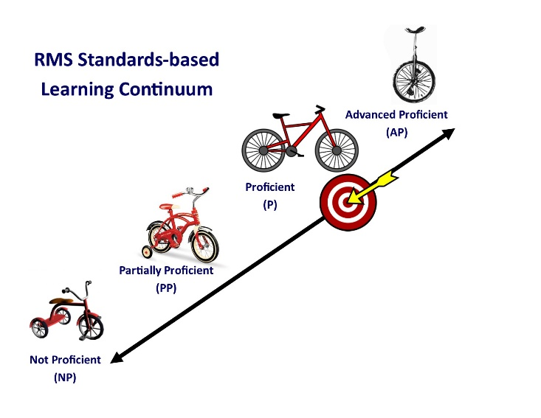
Academic Grading Rubric

AP – Advanced Proficient
P – Proficient
PP – Partially Proficient
NP – Not Proficient

Test Re-Takes:
Retake tests are a fantastic opportunity for students to learn from test feedback and master concepts they may have struggled with. Retakes are the responsibility of the student. Students will be able to retake summative assessments during class or advisory time. The following applies for all test retake opportunities:

- Due to RMS using standard based grading, students may be eligible for a retake on a particular assessment once, or several times throughout the year.
- If a specific standard is being assessed in quarter 1 and the child wishes to reach mastery, they may retake the assessment again. Furthermore, if that same standard is assessed once more in quarter 4, the child will still have the opportunity to master and retake an assessment on that standard until mastery is achieved.
Summative Assessment Retakes: Summative assessment retakes are available to all students, with the exception of AP and Honors classes, based on the following principles and process:

- The higher score is the only score of record
- Students must follow the retake process:
  - A written request by the student including an explanation for requesting the retake.
  - The student’s demonstration of effort to attain mastery learning which includes test corrections and caught-up homework.
i. Caught-up homework is defined as turning in all formative assignments by their original due date and having all assignments turned in before the summative assessment
ii. Formative assignments will still be accepted for a level of performance grade up to the date of the summative assessment.
iii. Effort must be made on ALL formative assessments. Turning in incomplete work does not demonstrate an effort to attain mastery learning. If work is turned in uncompleted it will receive NP for level of performance and will not count toward a summative retake.
  - The teacher’s approval for retake following steps a. and b.
  - The student’s arranging with the teacher for the retake.
  - Completion of the retake within a reasonable time (teacher discretion) frame, e.g., within1.5 weeks of the original summative assessment.
- Retakes should be in a different format from the original summative assessment.
- End-of-semester exams cannot be retaken.

Late Work, Missing Assignments, and Level of Performance:
- FORMATIVE ASSESSMENTS: Assignments will be accepted until the time a summative assessment is given. At that time, all missing assignments will fall within NP for level of performance. Furthermore, all missing assignments and late work will be given a learning quality evaluation. Learning quality measures student behavior and wiliness to achieve mastery. (For example, a student who completes all work on time will receive a “1” for consistency, but a student who fails to turn in work or fails to complete work will receive a “3” for needs improvement. See Learning Quality rubric for details.)Work completed and turned in as part of the requirement for a Summative Retake, will be accepted, but will not be given a level of performance.
- SUMMATIVE ASSESSMENTS: All assessments must be taken. NP will only be given for summative assessments under the following conditions:
  - The student earned a level of performance of NPon the assessment and did not qualify and/or chose not to retake the assessment and/or earned a NPon the retake of the assessment.
  - After given an opportunity to turn in or take the summative assessment at a later date due to circumstances, the student failed to do so.

Homework Policy
Students are expected to do their best on all homework assignments. In order to be eligible for a proficient level of performance, neatly completed homework is due at the beginning of the next class period unless specified otherwise in student planners. Students with missing or incomplete homework, papers, and projects will receive a lower level of performance credit once the assignment is completed and turned in. Assignments turned in after the corresponding summative assessment will receive an NP level of performance. (See Level of Performance rubric)

Absent/Make-up Work
Students who were absent are responsible for getting their missed assignments from the Homework/Absent folder, and turning in completed make-up work to the “Turn in bin” at the beginning or end of class periods. I usually provide make-up work time according to the number of days that they were absent. (For example, a student who was absent one day will have one day to make up the assignment after receiving it.) However, I am flexible in working with students if they have special circumstances.

Power School
I use the following assignment indicators in Power School regularly:
- M (missing) – an assignment has not been turned in on the assigned due date and will eventually result in an NP level of performance AND a “3” in learning qualities if not completed.
- L (late) – an assignment has been turned in, but earned a lower level of performance AND a “3” in learning qualities due to being late.
- If I return papers to you, you can assume they are recorded in Power School. Students please keep all assignments until the end of the semester.

Classroom Expectations:
  - Be Prompt
  - Be Prepared
  - Be Positive
  - Be Productive
  - Be Polite

* Note - Items listed in the student code of conduct are all expectations in this classroom

Consequences:
If a student chooses not to abide by the policies and procedures, the following steps will occur:
1st offense: verbal warning
2nd offense: meeting with me after class
3rd offense: Parent contacted and referral to the office if necessary

Consequences for poor choices will include a low learning quality evaluation, loss of privileges, written reflections, and/or after school detentions.

Student Contract for 7th grade Social Studies

I have read and understand what is expected of me in 7th Grade Social Studies.

Student Name________________________________________________________________
(Please print)

Student Signature: ________________________________________ date_______________

I have read and understand what is expected of my child in 7th Grade Social Studies.

Parent/Guardian Name________________________________________________________
(Please print)

Parent/Guardian Signature: _________________________________ date_______________

Please provide how you would like to be contacted if a need arises:

1) Parent/Guardian’s first and last name
______________________________________
- Home phone ____________________
- Cell phone ______________________
- Work phone _____________________
- Email address_________________________________

2.) Parent/Guardian first and last name (if different household than above)
________________________________________
- Home phone ____________________
- Cell phone ______________________
- Work phone _____________________
- Email Address____________________________________

Are there any special needs your child has that I should be aware of such as the following?
- Allergies_______________________________________________________________
- A learning disability ___________________________________________________
- ADHD _________________________________________________________________
- Other __________________________________________________________________
***Please return this sheet to me by September 10, 2019. Thank you for your cooperation and I look forward to making this a wonderful school year!

